**MODUL 3**

**GERBANG LOGIKA**

NAMA : SALMAA KHOIRUN NISAA’

NIM : L200180019

KELAS : A

1. **Percobaan 1. Gerbang AND**

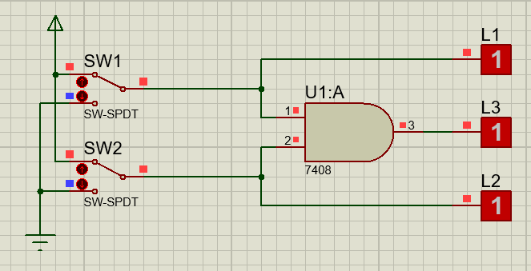

**Tabel Kebenaran :**

|  |  |  |  |  |
| --- | --- | --- | --- | --- |
| **SW 1** | **SW2** | **L1** | **L2** | **L3** |
| 0 | 0 | 0 | 0 | 0 |
| 1 | 0 | 1 | 0 | 0 |
| 0 | 1 | 0 | 1 | 0 |
| 1 | 1 | 1 | 1 | 1 |

**Diagram Waktu :**

|  |  |  |  |  |
| --- | --- | --- | --- | --- |
| **L1** |  |  |  |  |

|  |  |  |  |  |
| --- | --- | --- | --- | --- |
| **L2** |  |  |  |  |

|  |  |  |  |  |
| --- | --- | --- | --- | --- |
| **L3** |  |  |  |  |

1. **Percobaan 2. Gerbang OR**

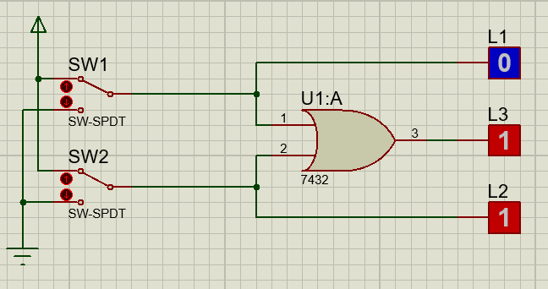

**Tabel Kebenaran :**

|  |  |  |  |  |
| --- | --- | --- | --- | --- |
| **SW 1** | **SW2** | **L1** | **L2** | **L3** |
| 0 | 0 | 0 | 0 | 0 |
| 1 | 0 | 1 | 0 | 1 |
| 0 | 1 | 0 | 1 | 1 |
| 1 | 1 | 1 | 1 | 1 |

**Diagram Waktu :**

|  |  |  |  |  |
| --- | --- | --- | --- | --- |
| **L1** |  |  |  |  |

|  |  |  |  |  |
| --- | --- | --- | --- | --- |
| **L2** |  |  |  |  |

|  |  |  |  |  |
| --- | --- | --- | --- | --- |
| **L3** |  |  |  |  |

1. **Percobaan 3. Gerbang NOT**

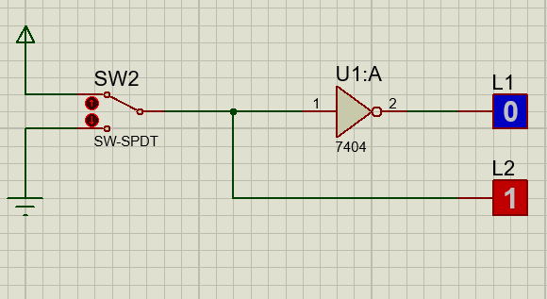

**Tabel Kebenaran :**

|  |  |  |
| --- | --- | --- |
| **SW 1** | **L1** | **L2** |
| 0 | 0 | 1 |
| 1 | 1 | 0 |

**Diagram Waktu :**

|  |  |  |
| --- | --- | --- |
| **L1** |  |  |

|  |  |  |
| --- | --- | --- |
| **L2** |  |  |

1. **Percobaan 4. Gerbang NAND**

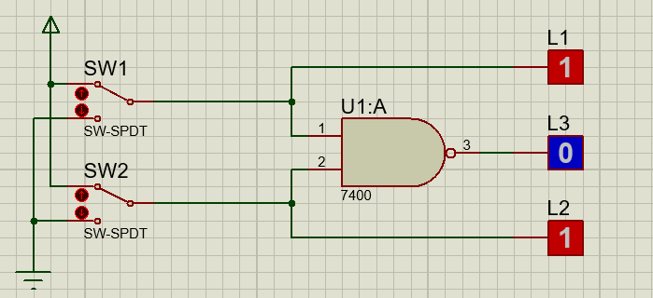

**Tabel Kebenaran :**

|  |  |  |  |  |
| --- | --- | --- | --- | --- |
| **SW 1** | **SW2** | **L1** | **L2** | **L3** |
| 0 | 0 | 0 | 0 | 1 |
| 1 | 0 | 1 | 0 | 1 |
| 0 | 1 | 0 | 1 | 1 |
| 1 | 1 | 1 | 1 | 0 |

**Diagram Waktu :**

|  |  |  |  |  |
| --- | --- | --- | --- | --- |
| **L1** |  |  |  |  |

|  |  |  |  |  |
| --- | --- | --- | --- | --- |
| **L2** |  |  |  |  |

|  |  |  |  |  |
| --- | --- | --- | --- | --- |
| **L3** |  |  |  |  |

1. **Percobaan 5. Gerbang NOR**

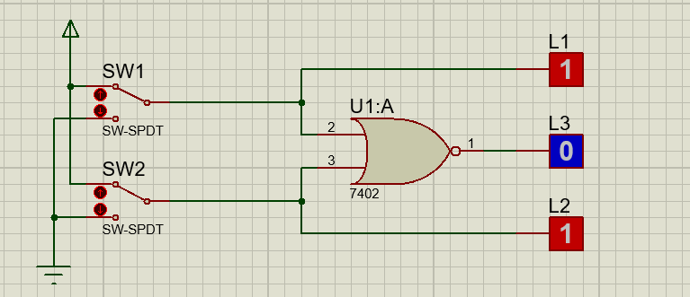

**Tabel Kebenaran :**

|  |  |  |  |  |
| --- | --- | --- | --- | --- |
| **SW 1** | **SW2** | **L1** | **L2** | **L3** |
| 0 | 0 | 0 | 0 | 1 |
| 1 | 0 | 1 | 0 | 0 |
| 0 | 1 | 0 | 1 | 0 |
| 1 | 1 | 1 | 1 | 0 |

**Diagram Waktu :**

|  |  |  |  |  |
| --- | --- | --- | --- | --- |
| **L1** |  |  |  |  |

|  |  |  |  |  |
| --- | --- | --- | --- | --- |
| **L2** |  |  |  |  |

|  |  |  |  |  |
| --- | --- | --- | --- | --- |
| **L3** |  |  |  |  |

1. **Percobaan 6. Gerbang XOR**

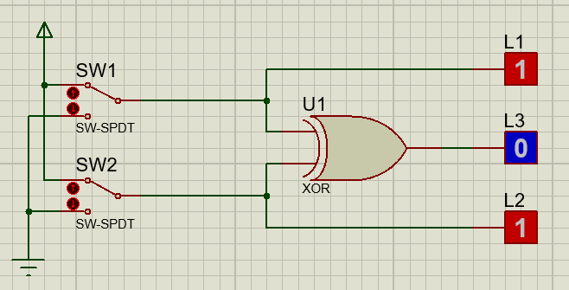

**Tabel Kebenaran :**

|  |  |  |  |  |
| --- | --- | --- | --- | --- |
| **SW 1** | **SW2** | **L1** | **L2** | **L3** |
| 0 | 0 | 0 | 0 | 0 |
| 1 | 0 | 1 | 0 | 1 |
| 0 | 1 | 0 | 1 | 1 |
| 1 | 1 | 1 | 1 | 0 |

**Diagram Waktu :**

|  |  |  |  |  |
| --- | --- | --- | --- | --- |
| **L1** |  |  |  |  |

|  |  |  |  |  |
| --- | --- | --- | --- | --- |
| **L2** |  |  |  |  |

|  |  |  |  |  |
| --- | --- | --- | --- | --- |
| **L3** |  |  |  |  |

1. **Percobaan 7. Gerbang XNOR**

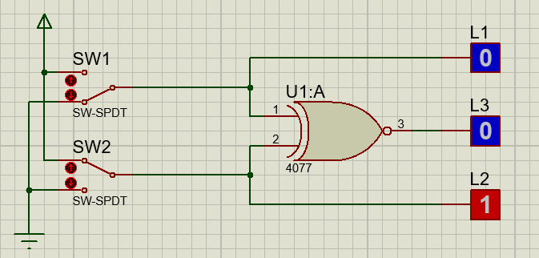

**Tabel Kebenaran :**

|  |  |  |  |  |
| --- | --- | --- | --- | --- |
| **SW 1** | **SW2** | **L1** | **L2** | **L3** |
| 0 | 0 | 0 | 0 | 1 |
| 1 | 0 | 1 | 0 | 0 |
| 0 | 1 | 0 | 1 | 0 |
| 1 | 1 | 1 | 1 | 1 |

**Diagram Waktu :**

|  |  |  |  |  |
| --- | --- | --- | --- | --- |
| **L1** |  |  |  |  |

|  |  |  |  |  |
| --- | --- | --- | --- | --- |
| **L2** |  |  |  |  |

|  |  |  |  |  |
| --- | --- | --- | --- | --- |
| **L3** |  |  |  |  |